Age of home < 20 years

Plus Market Area Code

Remove County Section Location

Neighborhood Codes for Market Areas 26-29

Neighborhood Codes (numeric) – All

Remove JUST value

Add Tax Percent for Building, Land, and Extra Features

Discovered some 2021 sales were incorrectly classified as “Qualified” sales in the data and has since been changed to “Unqualified” sales. Changed analysis to 2020 sales data.

Removed JUST value and added SUB using HashingEncoder

Changed SUB from HashingEncoder to TargetEncoder

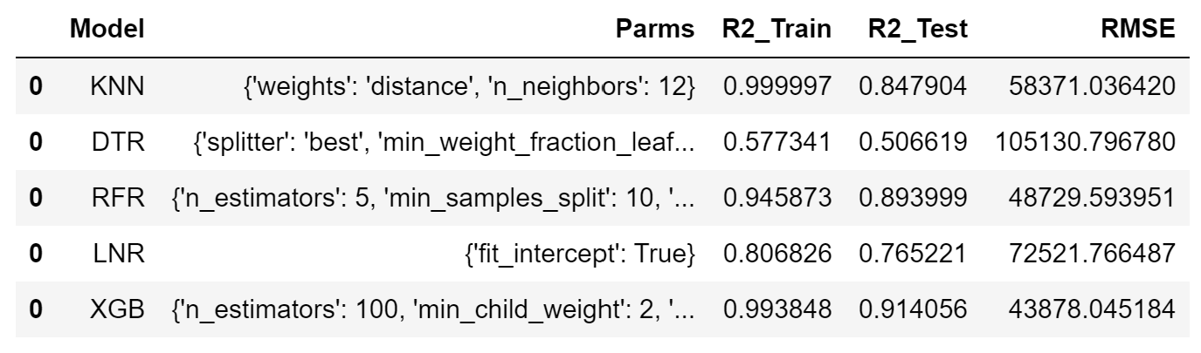

Refactor Code

Set Random Seed

3 years of sales (2018-2020)

11 years of sales (2010-2020)

3 years of sales (2018-2020) and all DOR codes

3 years of sales (2018-2020) and all Ages of homes

3 years of sales (2018-2020) and all numbers of beds/baths/stories/bldgs./units

1 year of sales (2020) and Market Area 26

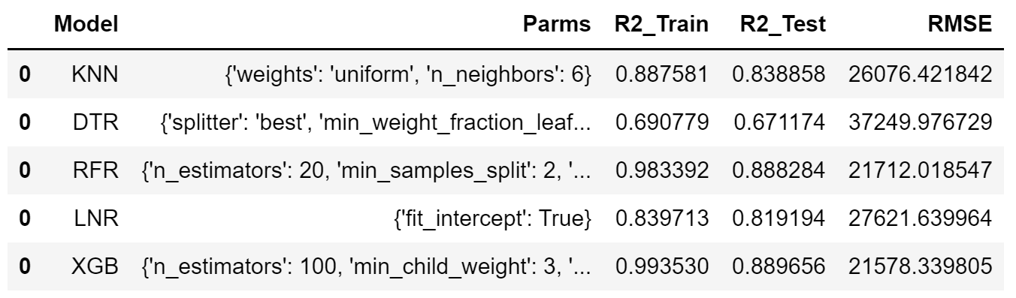

Change NBHC from float to One-Hot Encode

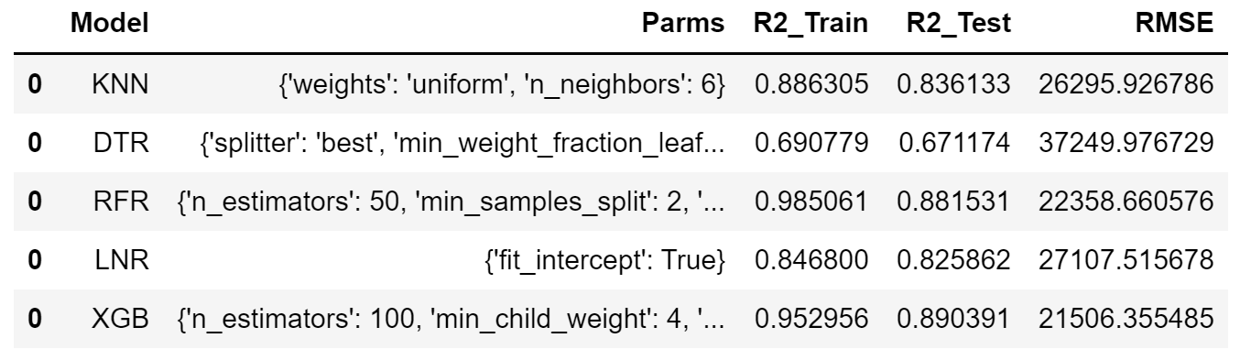

Change NBHC from One-Hot to Target Encode

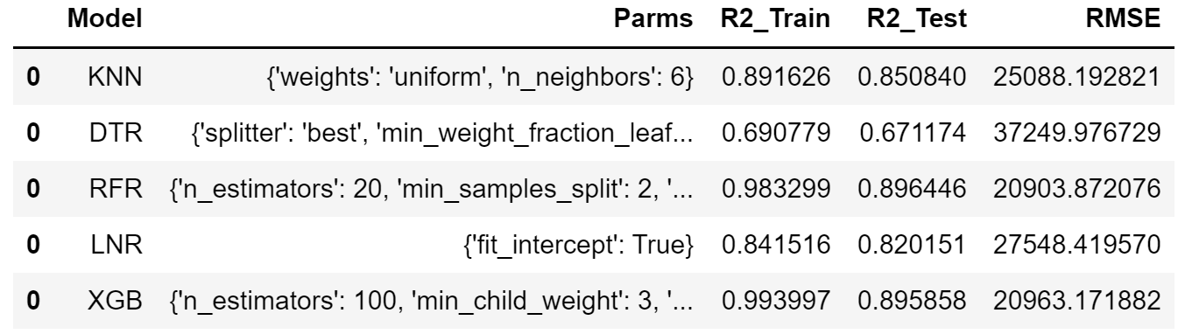

Adjust XGB hyperparameters

